2021 Winter CIS200 – Lab 3
Release date: Feb. 1, 2021
Due date: Feb. 8, 2021
Student Name:

Question 1 (3.0 points)

Suppose you work for a boss who is stingy about memory use and ask you to use only one unsigned char variable, x, for the representation of the binary status (ON or OFF) of 8 locations. (See a figure below.) The reason for this is that your boss wants to use your code in handling with multiple-million user information. In addition, your boss requires you to write a code for complete a number of steps as follows:

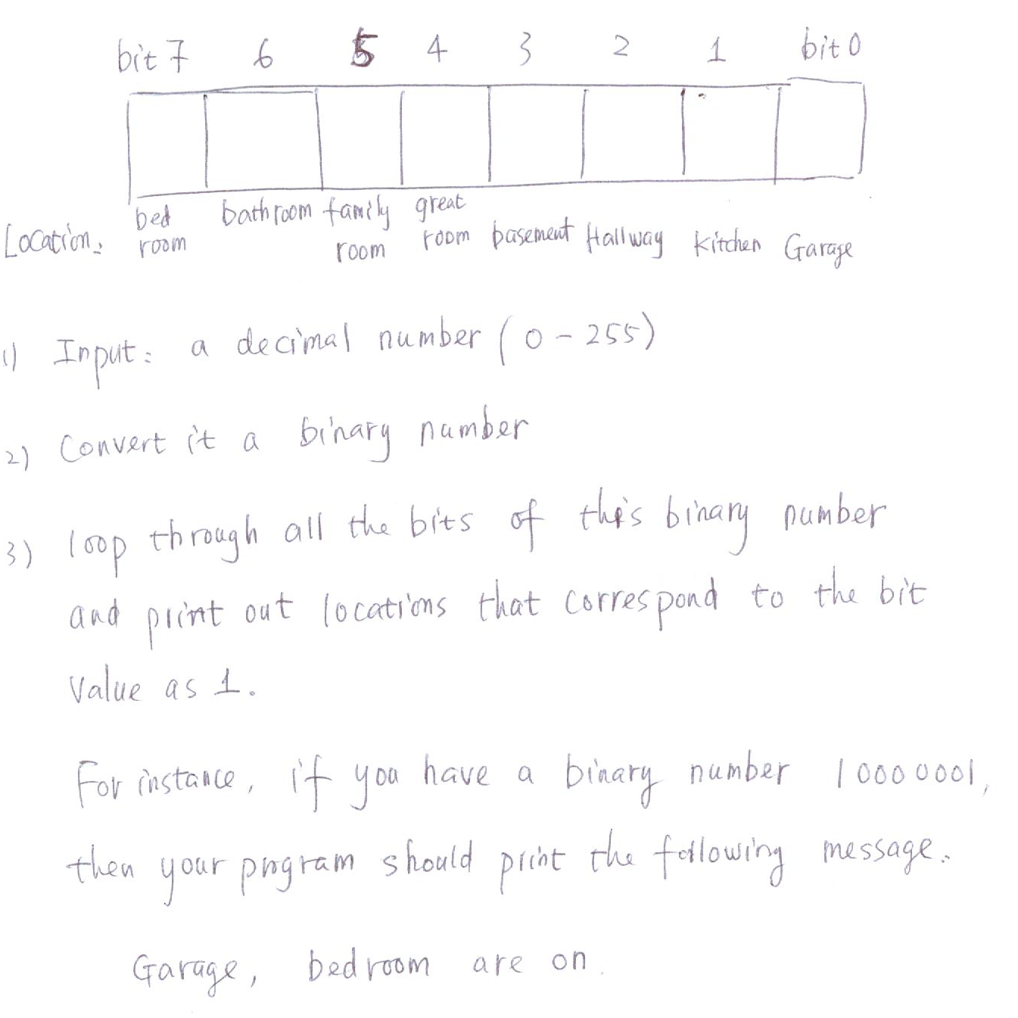

Test your program with the following input numbers:

- 3
- 13
- 133

Question 2 (3.0 points)

Write a program to determine whether the character entered is a capital letter, a small case letter, a digit or a special symbol. The following table shows the range of ASCII values for various characters.
Characters | ASCII Values
A – Z | 65 – 90
a – z | 97 – 122
0 – 9 | 48 – 57
special symbols | 0 - 47, 58 - 64, 91 - 96, 123 – 127

In your main( ), you should declare a char variable ch and get a user input from keyboard for ch. Based on the above ASCII table, print out a message to show that the input character is an upper case or a lower case or a digit or a special symbol.

User test inputs:
Y
t
5
*

Question 3 (4.0 points)
Given that Sale[NUM_ROW][NUM_COLUMN] is a two dimensional array of float-point type and the two constants are defined as follows:

#define NUM_ROW 4
#define NUM_COLUMN 4

float Value[NUM_ROW][NUM_COLUMN] =
{ 5.1, 5.2, 5.3, 5.4, 4.5, 4.6, 4.7, 4.8, 4.9, 3.0, 3.1, 3.2,
3.1, 3.2, 3.3, 3.4
};

Write a C++ main function that computes and prints out the following information about this 2d array:

- The minimum value of Value[][] array elements (1 points).
- The maximum value of the Value[][] array elements (1 points)
- The mean of all the Value[][] array elements (1 points).
- The values of four neighboring elements with respect to Value[i][j], where i and j represent the row and column, respectively. Your program should ask users to input i and j, and then the code should print out the values of all the four neighboring elements w.r.t. i and j. The four neighboring elements are defined as the elements at the left, right, up, and down positions adjacent to the element [i][j].

User test cases:
- i = 1, j=1
- i = 0, j =2
- i= 2, j=3

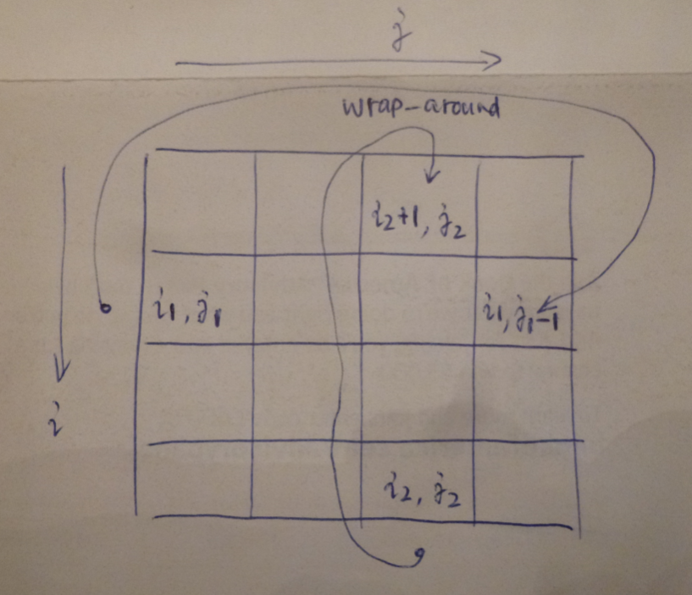

You need to print the results on computer screen and make a screenshot.

Hint: You should consider wrap-around when element[i][j] is located at the boundary of the matrix.

Row  Elements:0 | 1 | 2 | 3 | Column Elements:
5.1 | 5.2 | 5.3 | 5.4 | 0
4.5 | 4.6 | 4.7 | 4.8 | 1
4.9 | 3.0 | 3.1 | 3.2 | 2
3.1 | 3.2 | 3.3 | 3.4 | 3

Provide an MS word document or a pdf file with the following information:
- Cover page with lab number and title, your name, date
- Test data and expected results
- Running log/output (screen shots should be provided)
- Insert the source code and screenshots into the word document
- You should submit your work through Canvas site for cis 200 lab.
- The filename of the word document should follow the convention: FirstName_LastName_Cis200Lab3.doc or pdf.

